[Part of Acceptance Email]

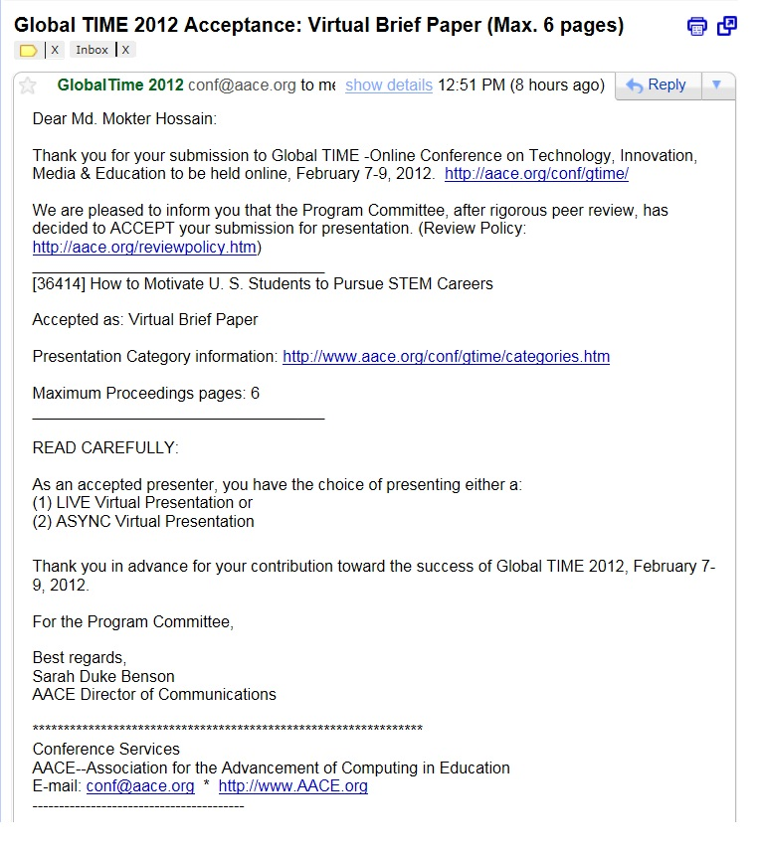
[Manuscript]

How to Motivate U. S. Students to Pursue STEM Careers

Md. Mokter Hossain

University of Nevada, Reno

E-mail: mokter@unr.edu

Michael G. Robinson

University of Nevada, Reno

E-mail: robinson@unr.edu

ABSTRACT: Science, technology, engineering, and mathematics (STEM) has been a powerful engine of prosperity in the United States since World War II. Currently, American students’ performance and enthusiasm in STEM education are inadequate for the U.S. to maintain its leadership in STEM professions unless the government takes more action to motivate a new generation of U.S. students toward STEM careers. Despite coherent actions taken by the government and various institutions, the U.S. cannot ensure the production of a sufficient number of experts in STEM fields to meet its’ national and global needs. The current situation is that the U.S. is largely dependent on the foreign-born STEM workforce. This paper starts with a deeper look at the participation rate of American Students in STEM Careers and the basis of career choices by the U.S. students. The discussion is driven by barriers and misconceptions about STEM education. It concludes with recommendations for how to motivate more U.S. students to pursue STEM careers.

Introduction
Science, Technology, Engineering, and Mathematics (STEM) includes some of the most versatile and important careers in the contemporary world. Most new developments that are making the world a better place to live in are from the contributions of STEM fields. As the world becomes more technologically developed, the economy, power, and leadership of the U.S. is becoming more heavily based on effective practice and the number of skilled workers in these fields, As a result, the success, security, and leadership position of a nation depends not only on the use of technology but also the number of native workers in STEM fields. The technology driven economy and skilled workforce in STEM fields is the driving force for innovation of a nation. The United States possesses the most innovative, technologically capable economy in the world. Despite a glorious record of achievement in technology, the U.S. lags behind many less developed nations in STEM education in elementary, secondary, and higher education. As the U.S. invests more money and effort to promote improvement in STEM education, the number of foreign students and workers in these fields is increasing significantly (Borjas, 2004; Kuenzi, 2008; National Center for Education Statistics, 2009).
In the proportion of 24-year-olds who earn degrees in STEM fields, the U.S. currently ranks 20th in the world (Kuenzi, 2008). Once, the leader in science and technology, the U.S. is now behind many countries on several measures in STEM education. Current progress is not satisfactory for the nation to address its ailing economic situation and continue global leadership in technology and innovation. It is assumed that many high-STEM-ability U.S. students fail to realize their full STEM potential at the high-school level, or many of them leave their career choice in STEM fields entirely at the college level. There exist a lot of magnet STEM programs nationwide that are largely responsible for developing much of the talent emerging from the public school system. These programs, however, are not necessarily available to underprivileged students, and some are being cut due to current budget restraints. According to Wasserman (2008), to retain these students in STEM and to enhance their high-school STEM experiences is simpler than recruiting additional students. These students could be considered as the low-hanging fruit in the National Science Board (NSB)'s efforts to produce the next generation of innovators. Sometimes their talent and potential are overlooked, under-developed, and underutilized. However, they should be a target group for the nation's strategy for developing a STEM workforce. This is apparently the only way to strengthen the economy and leadership of the nation; by preparing a substantive number of American citizens capable of working and leading in the nations science and technology sectors.
Although many U.S. students excel in STEM, as a whole, U.S. student performance in international comparisons on science and mathematics tests is consistently below average or in the third quartile (PCAST, 2010). The situation is that STEM education in the U.S. is failing to motivate American citizens to attain sufficient skills and knowledge required to meet the century’s challenging economic and leadership needs (National Science Board, 2007). There are wide disparities in STEM achievement among various ethnic groups and too many American students and parents believe that STEM subjects are too difficult, boring, or exclusionary (PCAST, 2010). Research evidence indicates that many of the proficient American students, especially the minority and women groups, have been switching their career choice in STEM fields toward other professions (Denson & Hill, 2010). Although Hispanics and black students in America’s college-age population are increasing, their participation rates in STEM fields are significantly lower than those of White and Asian Americans (Sanders, 2004).
As the nation continues to advance through the first quarter of the 21st century, there is a growing need for educators to be less dependent on the foreign or foreign-born STEM workers, and to take appropriate actions to inspire and prepare native-born American students towards STEM education. The rest of the paper addresses the following: Statement of the problem; a closer look at the participation rate of American students in STEM careers; the basis of career choices by U.S. students; barriers and misconceptions toward STEM Education in the U.S. It closes with some recommendations to motivate more U. S. students to pursue teaching in STEM areas.

Statement of the Problem
Over the past two decades the U.S. STEM workforce has grown at more than four times the rate of total employment. At the same time, the proportion of U.S. citizens qualified to fill STEM jobs is stagnating (University of California, 2010). According to a 2004 high powered U.S. Education Commission, the STEM workforce in the U.S. largely depends on foreign-born mathematicians, scientists and engineers (Sanders, 2004). In this rapidly growing competitive market, industry prefers graduates who have the potential to meet their research and development needs and compete effectively with their counterparts worldwide.
Too many highly paid STEM jobs are now occupied by the foreign or foreign-born workers in the United States. The overall situation is a warning that it is less likely that the U.S. will maintain its local and global leadership in STEM professions unless the government takes remedial action to produce or import enough experts in these fields. As the nation continues to advance through the second decade of the twenty-first century, there is a growing need to, not only depend on the foreign-born workforce in STEM fields, but also to take appropriate initiatives to prepare local expertise in these fields. This, problem is causing difficulty for American educators and legislators during the recovery of the current recession and it hinders the U.S. ability to sustain its’ competitive position. Thus, the question arises as to whether the U.S. should continue its dependence on other countries for required STEM workers or take action to motivate more American middle and high school students toward the STEM pipeline. May be both are needed to generate enough scientists, technologists, engineers, and mathematicians to create the new ideas, products, and entirely new innovations in the 21st century.

The Participation Rate of American Students in STEM Careers
The current pipeline and participation rates for U.S.-trained STEM professionals are thought to be inadequate to meet the nation’s needs. Due to lack of proper motivation, many high-STEM-ability students fail to realize their full STEM potential in high-school or leave the STEM track in college. According to the Engineering Workforce Commission (EWC) report of 2005, over the past 20 years, the total number of students who received bachelor's degrees in engineering declined by 19.8% in the U.S. During the 2000–10 period, employment in science and engineering occupations would have been expected to increase about three times faster than the rate for all occupations. According to another report from the Computing Research Association, enrollment in undergraduate degree programs in computer science is more than 50% lower than it was five years ago. Between 2005-06 and 2006-07, the number of new students declaring computer sciences as a major fell 43%, to 8,021 (eSchool News, 2008a). The report did agree with the U.S. Bureau of Labor Statistics in 2008 that between 2006 and 2016, 854,000 professional IT jobs will be added, an increase of about 24% with the estimated 1.6 million IT jobs replaced in the 10-year period fields. According to Gellos, a spokesman for Microsoft Corp., “All companies have that person down the hall to help with computer issues” (eSchool News, 2008a). He did regret that among the students earning bachelor’s degrees in Washington state, only 14% are graduating with the skills the company needs.
In a 2008, a public high school authority in the U.S. discovered an extremely low level of interest for participating in STEM related career academics in high school among middle school students; however, the students showed higher interests in arts, literatures, business, and entertainment related careers, specially the girls (Rogers, 2009). Thus, it sometimes becomes a challenge for many high schools in the U. S. to get a sufficient number of students to choose to enroll in STEM related academics. If low enrollment in STEM fields and low interest in STEM academics continues, all high school academics that lend to STEM major will be at great risk (Rogers, 2009). The Nashville Area Chamber of Commerce in Tennessee, and numerous national sources point out that the U.S. needs more workers in STEM fields. Experts warn that the United States’ apathetic performance in encouraging students to enter STEM careers can complicate the troubles of the nation’s already ailing economical situation (Ramirez, 2008).
Furthermore, science and mathematics teachers face inadequate support, including appropriate professional development as well as interesting and intriguing curricula. School systems lack tools for assessing progress and rewarding success. The Nation lacks clear, shared standards for science and math that would help all actors in the system set and achieve goals. As a result, too many American students conclude early in their education that STEM subjects are boring, too difficult, or unwelcoming, leaving them ill-prepared to meet the challenges that will face their generation, their country, and the world. Studies find that many U.S. teachers are not well prepared to teach math and sciences (EducationNews, 2010). Future mathematics teachers are getting weak training and are not prepared to teach the demanding curriculum needed for U.S. students to compete internationally
If too many students continue to pursue degrees and careers in fields other than STEM related areas, the U.S. will find it difficult to compete in the global economy. Furthermore, the U.S. will not be able to meet its future workforce needs. The U.S. needs 400,000 new graduates in all STEM fields by 2015 (Obama, 2009). Since only 15% of all college graduates currently choose STEM as majors or minors, which impacts American competitiveness, there is a projected shortfall of more than 280,000 math and science teachers by 2015 (eSchool News, 2008b). Microsoft reports that only 14% of students graduating with bachelor’s degrees in Washington state have the skills that they need (University of California, 2010). Without a solid foundation in STEM, students will not be qualified for many jobs in the workplace – including many jobs beyond traditional engineering and science.

The Basis of Career Choices by U.S. Students
A great number of U.S. students believe that a college degree is an excellent advantage in finding a rewarding job. But many more do not consider postsecondary education as the optimal or even a possible choice. About one-half of U.S. students leave high school without the knowledge or skills needed to find and maintain a job, and one-third of them are not prepared for even entry-level work (Levinson & Palmer, 2005). Many American students and their parents believe that most of the STEM studies require significant investment and hard work in education. Students who do commit themselves from the very beginning of middle or high school and have the opportunities to take high school or vocational courses in science and mathematics do succeed in the STEM path in their future studies.
A 2004 study found that 72.2% of U.S. parents indicated that the basis of career choice should be based upon a combination of interests/abilities and the job market; 27.6% responded that career choices should be based solely upon interests/abilities, and only 0.2% stated that career choices should be based upon the labor market (Taylor, Harris, & Taylor, 2004). The study found more than 90% of parents had little to very little influence on their college-age children’s career decision; fewer than 10% parents had a great influence on career decision making. Parental support and encouragement were found as influencing factors in children’s vocational outcome. The study also found that regarding influence on students, the father and mother were ranked as the first two, the teacher as the third, and the counselor as the fourth in children’s choice for career development. However, most of the parents did agree that they did not have or should not have more influence on their children’s career decisions (Taylor et at., 2004).

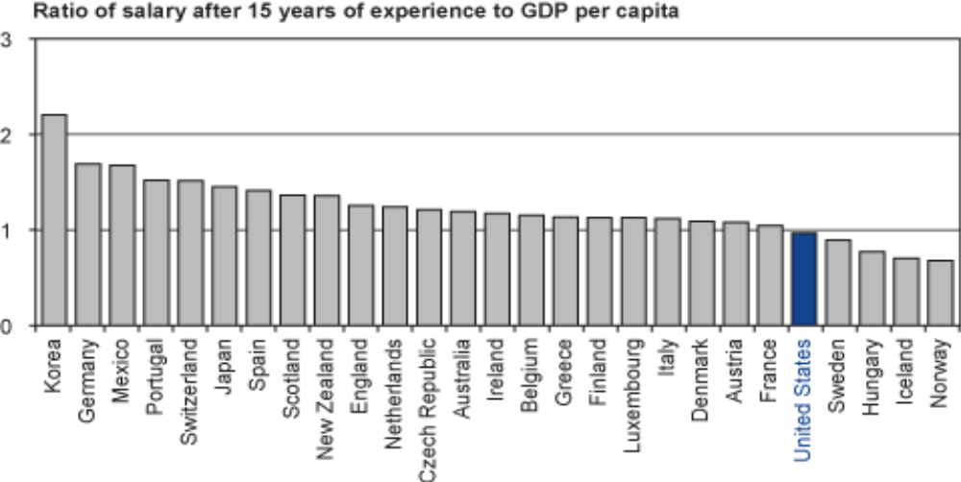
Figure 1. Secondary teachers’ salary relative to GDP in OECD nations.
Source: Organization for Economic Cooperation and Development, 2007 reported in PCAST, 2010

According to a U.S. Bureau of Labor Statistics, in the 2005 FY, STEM workers, as a group, earned about 70% more than the national average, and every major group of STEM workers enjoyed overall median earnings that were above the national average. Fresh college and university graduates with a degree in STEM fields believe that they will not be paid adequately if they teach in a school or college. For instance, in 2005, biophysicists and biochemists, which often have a Ph.D., had median earnings of $71,000; biological technicians, who often have an associate degree or less education, earned a median of $34,270 (Terrel, 2007).
However, many students who graduated with a STEM degree believe that teaching in a middle and high school is more socially responsible but is not paid adequately. For instance, median salary offered for the fresh college graduates for teaching in elementary public schools was $30,000, and the median salary for fresh secondary teachers was $36,000. By contrast, the median salary offered to fresh college graduates in certain STEM-related fields, including physics, computer science, accounting, and engineering, is currently more than $60,000 (PCAST, 2010). Moreover, most of the teaching positions demand a teaching license and or a teacher education degree that many STEM graduates do not want to acquire.
In addition, STEM teachers’ salaries do not keep pace with salaries paid to other STEM professions (PCAST, 2010). For instance, between 1993 and 2003, the median salary for high school science and mathematics teachers increased by 8% adjusted for inflation, while, during the same period, the salary for other STEM professions increased by 21 to 29 percent (National Science Board, 2008). In international comparison, teachers in the U. S. are paid less than in many developed countries, even though they have to do more challenging and responsible duties, and work more hours on average (Organization for Economic Co-operation and Development, 2009). According to the finding of PCAST (2010), “relative to per capita GDP, the U.S. ranks in the bottom third of OECD countries in terms of teacher salary.” Figure 1 shows that the U.S. teachers’ are paid less than half of Korean teachers, and lag behind more than half of the 33 OECD countries including Mexico, Japan, Czech Republic, Italy, Austria, and France. Thus, it is very likely that many graduates with a STEM degree either do not choose a teaching position or leave within the first few years of their teaching career to a non-teaching position.

Barriers and Misconceptions toward STEM Education in the United Sates
According to the National Center on Education and the Economy (NCEE, 2006), “the core problem in U.S. STEM education and training systems is that they were built for another era, an era in which most workers needed only a rudimentary education” (p. 8). The NCEE believes that teachers who educate elementary to high school level students get their information and attitudes about STEM disciplines from college and university level courses taken in the teacher education programs. However, technology has not reached its potential in teacher education curricula nationwide. Many newly graduated teachers often do not have sufficient experience to use computers in teaching-learning processes (Kurz & Middleton, 2006). A study showed that teacher preparation for technology integration was minimal (Watts-Taffe, Gwinn, Johnson, & Horn, 2003). Amore recent study revealed that many technology preparation classes only adequately prepare preservice teachers with lower-level technology skills that do not provide preservice teachers with adequate knowledge to provide sufficient technology-based instructions in their classrooms (Brush, Glazewski, & Hew, 2008).
It is also thought that U.S. STEM education faces barriers and misconceptions that greatly hinder students’ motivation and achievement at all levels. Most of the barriers are related to curriculum, credit and funding issues, lack of qualified teachers, inadequate policies to recruit and retain STEM-Educated teachers, difficulty to retain teachers with a STEM background, difficulty in conducting research while teaching in the classroom, difficulty in continuing to learn about STEM areas while teaching in the classroom, lack of adequate preparation for teachers in higher education, classroom time constraints and difficulty in attracting and keeping kids in STEM careers, etc. These barriers fueled by some of the following misconceptions against STEM education in U.S. public schools. These include the following long list: STEM education is just another “fad” in education and will soon go away; colleges will not accept credits for high school courses called STEM; technology means the ability of basic computing and Internet browsing, STEM education consists only of the two bookends – science and mathematics; STEM education addresses only workforce issues; technology education and engineering are disparate and troublesome; mathematics education is not part of science education; engineers and technology education teachers cannot teach science or mathematics; STEM education include a lot of laboratory work or the scientific method; all STEM educated students will be forced to choose technical fields because they do not have a liberal arts foundation; etc (Setda.org, 2008). In addition, STEM studies seem to be very hard for many students.
There are severe troubling weaknesses, gaps and disconnection among the quality of math and science instructions in the early grades, the performance of high school students on international tests, and the content and harshness of pre- and in-service teacher education programs in the colleges and universities in the United States (Sanders, 2004). Too many elementary and middle school students are not being equipped to achieve expected goals in science and mathematics. A significant number of elementary school teachers lack confidence in their ability to teach mathematics and science. The problem is particularly severe in the elementary grades and also serious for middle and high schools (National Center for Education Statistics, 2009). During the 2007-08 school year, only 56% of K-12 public school science and mathematics teachers held undergraduate and/or graduate degrees in science or science education, or mathematics or mathematics education (PCAST, 2010).
Among the nation’s estimated 426,000 middle and high school STEM teachers, each year about 25,000 of them leave their teaching profession (Ingersoll & Perda, 2010). While reasons for leaving job are numerous, nearly two-thirds of them cite job dissatisfaction as their reason for leaving. Due to low remuneration but high accountability and workload, and lack of professional support, more than 40% of beginning science and math teachers leave their jobs in the first five years (Ingersoll & Perda, 2010; National Science Teacher Association, 2008; Woullard & Coats, 2004). Although many of them reenter teaching in different schools or locations, or switch to a different branch of STEM careers, to counter the net turnover rate of STEM teachers, the U.S. still needs to attract more students to STEM fields and ensure an ongoing annual average need for 25,000 new STEM teachers (PCAST, 2010).
The issues are not only due to the quantity and quantity of STEM teachers. There is a crucial issue of quality of teacher education programs as well. Many pre- and in-service teacher education programs prepare their graduates with insufficient skills on technology usage. As a result, many newly graduated teachers do not have sufficient experience to use computers in the teaching-learning processes (Kurz & Middleton, 2006). A 2008 study found that many technology preparation classes adequately prepare preservice teachers with lower-level technology skills but do not provide preservice teachers with adequate knowledge to provide sufficient technology-based instructions in their classrooms (Brush et al, 2008). Even, among teachers who obtain college or university degrees, many do not acquire a strong background in technology integration with pedagogical training, and even among the small fraction of teachers trained deeply in pedagogy in STEM fields, there is a little evidence to evaluate the quality of instructions they received in STEM content or STEM pedagogy (PCAST, 2010).

How do we motivate more U. S. students to pursue teaching in STEM areas?
To address the barriers, misconceptions, and problems of STEM education, we needs to target STEM education components for students at all levels from elementary to graduate levels. We particularly need to target the preservice teachers who will become the future STEM undergraduate, graduate or faculty school teachers. To meet the needs of a scientifically and technologically literate work-force, meaningful preparation of STEM teachers needs to be considered an undoubted necessity. To increase young students’ interest and enthusiasm in STEM careers there are some actions that can be taken. They include the following: Organizing fundraising events with the community or other projects that increase budgeting and math skills; teaching youth at science summer camps or after-school programs; getting students to join math and science clubs; exploring technology hobbies among school children; helping them to participate in science fairs; basic computing and internet browsing; including them in internet forums and social networking; giving them books and magazines on science and mathematics; motivating them to pursue science and engineering careers; and helping them to learn about computer parts; etc (Setda.org, 2008). Moreover, students pursuing degree or certification courses in STEM related subjects should be given additional scholarships or financial support by the government or concerned institutions.
The U.S. federal government has pursued some of these initiatives and if they are successfully implemented by 2020, the U.S. will once again have the prospect for the highest proportion of college graduates in the world. The tax credit and grant programs are some of the programs initiated to make U.S. college education more affordable. They can greatly enhance the U.S. ability to compete for the high-wage, high-tech jobs of the future and to foster the next generation of the STEM workforce (Obama, 2009). The U. S. 2010 budget provided $115 million for the Department of Energy (DOE) to launch a program jointly with the National Stock Exchange (NSE) to inspire tens of thousands of American students to pursue STEM careers, particularly in clean energy (Johnson, Chubin, & Malcom, 2010). Even as the United States focuses on low-performing students, it should devote considerable attention and resources to all of our most high-achieving students from across all economic and ethnic groups. In the words of President Obama, “We must educate our children to compete in an age where knowledge is capital, and the marketplace is global.” (Obama, 2009)
To meet U.S. needs for a STEM-capable citizenry, a STEM-proficient workforce, and future STEM experts, the U.S. should focus on the following goal: The U.S. should prepare all students, especially minorities and girls who are underrepresented in these fields, to become more motivated and proficient in STEM subjects. To support this goal, partnership and collaboration of private and philanthropic groups with local and state government is essential. To motivate a great number of students and the non-STEM workforce to join the STEM pipeline, a number of steps at various levels should be taken and monitored closely. Collaborating with other education organizations, the private sector, and local community organizations is the most effective and promising way to accomplish the shared vision for motivating workers to join the STEM pipeline. Initiatives should be started to promote education in the related areas so that students who are enrolled in the industrial areas can do their internships while they are being prepared to study STEM fields in college. Most importantly, students, teacher and educators at all levels should acknowledge that STEM careers require significant investments and hard work during preparation. Students who do commit themselves from the very beginning of middle school and have the opportunities to take high school or vocational courses in science and mathematics can succeed in the STEM path in their future studies.
STEM initiatives should be monitored by the Department of Education and the federal agencies such as the National Science and the Foundation, and the National Council of Teachers of Mathematics, for effective STEM education in K-12 levels. The Federal Government must actively engage with each of these partners, who must in turn fulfill their own distinctive roles and responsibilities. According to the PCAST (2010), in recent decades, relatively little Federal funding has been targeted toward catalytic efforts which have the potential to transform STEM education. Too little attention has been paid to replication and scale-up to disseminate proven programs widely. And, too little capacity at key agencies has been devoted to strategy and coordination.
Thus, coherent strategy and sufficient leadership should be taken by the federal government. The Federal Government should provide vigorous support to the state-led effort to develop common standards in STEM subjects by providing technical and financial support to states for high-quality professional development that is aligned with shared standards and the development, evaluation, administration, and ongoing improvement of assessments aligned to those standards. Most importantly, the Federal Government should provide vigorous support in setting goals that ensure the recruitment, preparation and induction support of at least 100,000 new middle and high school level STEM teachers with majors in STEM fields and strong content-specific pedagogical knowledge, by 2020 (PCAST, 2010).
Last, the U.S. must provide more investment in supporting teacher preparation programs that provide strong content and pedagogical knowledge in STEM subjects. In making investments, special focus should be given to programs that are scalable, because they will have the greatest impact in terms of the number of teachers produced and the greatest opportunity for learning about elements of successful programs (PCAST, 2010).

Conclusions
Despite coherent actions taken by educators, government, and various organizations, the U.S. cannot be certain of producing and certifying the quantity and quality of students, teachers, and professionals in STEM fields needed to meet the nation’s current demand. The overall situation indicates it is unlikely the U.S. will maintain its local and global leadership in science, math, and technology professions unless federal planning takes remedial action to produce nationally or import enough experts in these fields. This is not a satisfactory outlook for American educators and legislators who are attempting to recover from the current economic hardship and to ensure sustainability as a high technology nation. A vital question is whether the U.S. education system and job markets are failing to motivate and encourage Americans students to pursue STEM education and careers in these fields.
Success in STEM requires both technical and nontechnical skills and dispositions. Curiosity, the ability to think logically and creatively in problem-solving, communication skills, and the ability to work in teams are all required to succeed in STEM careers. Mathematics and science knowledge are an important base for all STEM workers. Students need to be inspired in STEM subjects beginning in the middle school grades with coursework and extracurricular activities focusing on honing problem-solving skills in the high school grades. After high school, STEM career requirements are more specific to the specific occupations.
The solution to the STEM education problem should be handled in an interdisciplinary manner, which must be grounded in the STEM discipline departments as well as the Colleges of Education and Human Development. STEM education should be considered as a targeted education component for graduate students who will later after work experience become the future STEM undergraduate and graduate faculty. Meaningful preparation of K-12 and higher education STEM faculty should be considered as an undoubted necessity to meet the needs of a scientifically and technologically literate work-force in a modern and technology driven nation.

References

Borjas, G. J. (2004). Do Foreign Students Crowd Out Native Students from Graduate. NBER Working Paper No. w10349. Retrieved March 12, 2010, from http://papers.ssrn.com/sol3/delivery.cfm/ nber_w10349.pdf?abstractid=515243
Brush, T., Glazewski, K. D., & Hew, K. F. (2008). Development of an instrument to measure preservice teachers’ technology skills, technology beliefs, and technology barriers. Computers in the Schools, 25(1-2), 112-125.

Denson, C, D, & Hill, R. B. (2010). Impact of an Engineering Mentorship Program on African-American Male High School Students’ Perceptions and Self-Efficacy. Journal of Industrial Teacher Education, 47(1), 99-127.

EducationNews (2010, April, 15). U.S. Teachers Not Well Prepared to Teach Mathematics, Study Finds. Retrieved October 17, 2010, from http://www.educationnews.org/ed_reports/edu_assoc_articles/91006.html
eSchool News. (2008a, June 24). Fewer students seek tech-related degrees, Retrieved February 16, 2010, from http://www.eschoolnews.com/news/top-news/?i=54247;_hbguid=900b8324-daf2-46d3-b631-ca35461b9736.
eSchool News. (2008b, July 18). U.S. behind in doubling science grads, E-School News, Retrieved February 16, 2010, from http://www.eschoolnews.com/news/top-news/?i=54607.
Ingersoll, R., & Perda, D. D. (2010). Is The Supply of Mathematics and Science Teachers Sufficient? American Educational Research Journal, 47(3), 563-594. Retrieved November 12, 2010, from http://aer.sagepub.com/content/early/2010/05/13/0002831210370711.full.pdf+html
Johnson, R. Y., Chubin, D. E., & Malcom, S. M. (2010). Education and Human Resources in the FY 2010 Budget: Investing in the Future of STEM Education.Research and Development FY 2010, AAAS Report XXXIV: Chapter 4, Intersociety Working Group, American Association for the Advancement of Science (2009). Retrieved December 18, 2011 from http://www.aaas.org/spp/rd/rdreport2010/ch04.pdf
Kuenzi, J. J. (2008). Science, Technology, Engineering, and Mathematics (STEM) Education: Background, Federal Policy, and Legislative Action. CRS report for Congress. Retrieved April 18, 2009 from http://www.fas.org/sgp/ crs/misc/RL33434.pdf.
Kurz, T. & Middleton, J. (2006). Using a functional approach to change preservice teachers’ understanding of mathematics software. Journal of Research on Technology in Education, 39(1), 51-71.
Levinson, E. M., & Palmer, E. J. (2005). Preparing Students with Disabilities for School-to-Work Transitions and Postschool Life. Retrieved April 10, 2010 from http://www.nasponline.org/resources/principals/Transition%20Planning%20WEB.pdf
National Center on Education and the Economy (2006). Tough Choices or Tough Times: Report of the New Commission of the Skills of American Workforce. Washington, DC: John Wiley & Sons, Inc.
National Center for Education Statistics. (2009). The Condition of Education. Retrieved November 12, 2010, from http://nces.ed.gov/programs/coe/2010/section5/indicator39.asp
National Science Board. (2007). A National Action Plan for Addressing the Critical Needs of the U.S. Science, Technology, Engineering, and Mathematics Education System. Retrieved February 16, 2010, from http://www.educause.edu/Resources/ANationalActionPlanforAddressi/174272
National Science Board. (2008). Science and Engineering Indicators: 2008. Arlington, VA: National Science Foundation.
National Science Teachers Association (NSTA). (2008). NSTA New Science Teacher Academy. Retrieved December 12, 2008, from http://www.nsta.org/academy/
Obama, B. (2009). What Science Can Do. ISSUES in Science and Technology, 25th Anniversary Issue, 25(4), 23-30.
Organization for Economic Co-operation and Development [OECD]. (2009). Education at a Glance 2009: OECD Indicators. Washington, DC: OECD. Retrieved March 12, 2010, from http://www.oecd.org/edu/eag2009.
Patrick, S., & Thomas, W. R. (2009). Breaking Away From Tradition: E-education expands opportunities for raising achievement. Technology Counts, 28(26).
President’s Council of Advisors on Science and Technology (PCAST). (2010). Prepare and Inspire: K-12 Education in Science, Technology, Engineering, and Math (STEM) for America’s Future. Retrieved November 13, 2010, from http://www.whitehouse.gov/sites/default/files/microsites/ostp/pcast-stemed-report.pdf
Ramirez, E. (2008). How to Solve Our Problem with Math. U.S. News and World Report, December 4, 2008. Retrieved March 15, 2009, from http://www.usnews.com/articles/education/high-schools/2008/12/04/how-to-solve-our-problem-with-math.html
Rogers, S. (2009, September). Rapid Prototyping: A Strategy to Promote Interest in STEM Careers. Paper Presented on U.S.-Turkey Workshop on Rapid Technologies. Retrieved February 16, 2010, from
Sanders, T. (2004). No Time To Waste: The Vital Role of College and University Leaders in Improving Science and Mathematics Education. Retrieved February 16, 2010, from www.ecs.org/html/Document.asp?chouseid=5480
Setda.org. (2008). Science, Technology, Engineering & Math. Retrieved February 16, 2010, from http://www.setda.org/c/document_library/get_file?folderId=270&name=DLFE-257.pdf
Taylor, J., Harris, M. B., & Taylor, S. (2004). Parents Have Their Say… About Their College-Age Children’s Career Decision. Retrieved April 10, 2010 from http://www.uncw.edu/Stuaff/career/documents/ parentssay%5B1%5D.pdf
Terrel, N. (2007). STEM Occupations. Occupational Outlook Quarterly, Spring, 2007, 26-33. Retrieved February 16, 2010, from www.bls.gov/opub/ooq/2007/spring/art04.pdf
University of California. (2010). Degrees of Success: Bachelor’s Degree Completion Rates among Initial STEM Majors. Retrieved February 16, 2010, from http://heri.ucla.edu/nih/HERI_ResearchBrief_OL_2010_STEM.pdf
Wasserman, L. (2008). Compiled Perspectives on STEM Education. Retrieved February 16, 2010, from http://www.nsf.gov/nsb/meetings/2009/0824/Louis_Wasserman_Compiled_Perspectives_on_STEM_Education.pdf
Watts-Taffe, S., Gwinn, C. B., Johnson, J. R., & Horn, M. L. (2003). Preparing preservice teachers to integrate technology with the elementary literacy program. The Reading Teacher, 57, 130-138.
Woullard, R., & Coats, L. T. (2004). The community college role in preparing future teachers: The impact of a mentoring program for preservice teachers. Community College Journal of Research & Practice, 28(7), 609-624.

